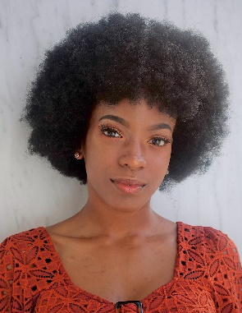
jmitche5@umd.edu
Jasmine A. Mitchell

Height: 5’3” Weight: 115 lb Hair: 4B texture/ Black Eyes: Brown

THEATRE
Babel | Collaborator/  Performer | University of Maryland,  Prague, Berlin, U.K.
Hamlet | Hamlet | University of Maryland.
Rapunzel | Rayven/ Rapunzel | University of Maryland
Near Death Experience | Jasmine | Charm City Fringe Fest
Prometheus Unbound | Asia | University of Maryland
What Happens To The  Nice Guy? | Marianne | University of Maryland
The DMV | Receptionist | University of Maryland
Plan A | Monica | University of Maryland
Dry Land | Swimmer | Forum Theatre

TRAINING
University of Maryland  B.A. Theatre  Vocal Performance Minor  May 2020 | Directing I  Viewpoints  Voice (Linklater)  Voice Coaching | Scot Reese  Jennifer Barclay  Lisa Nathans  Sheri Feldman

SKILLS
Language: French (Basic), Southern dialect
Voice: Soprano, Can read music
Other: Ballet (beginner), Post-modern dance, Violin (Proficient), Photoshop, DSLR Camera, Graphic Design, Costume Design, Ear wiggling, Wicked Witch cackle

